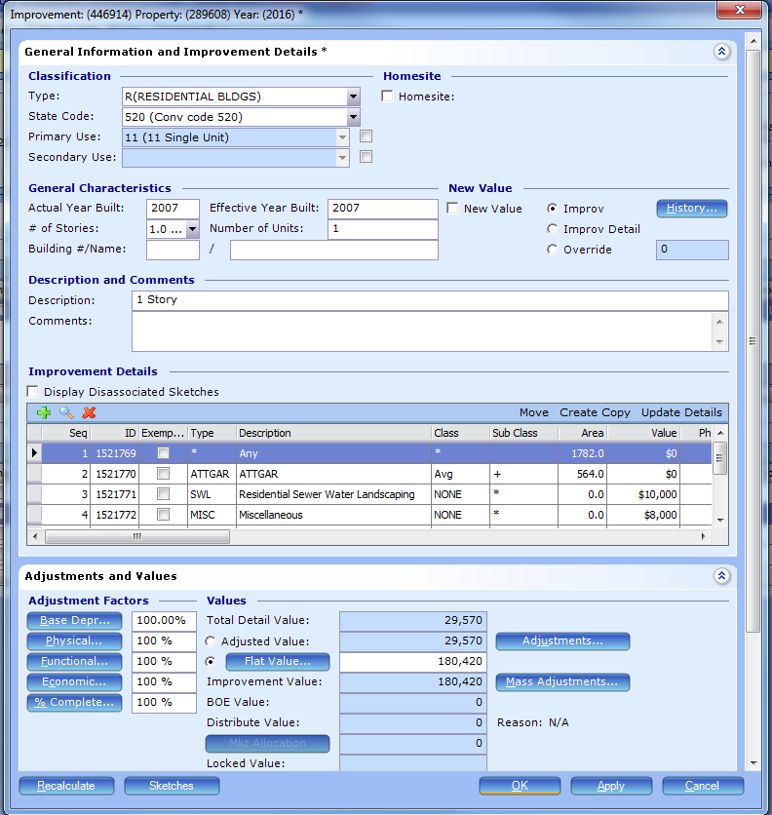

New Value
Improv will make a change to all details, but Improv Detail will only flag the change in detail to new construction.
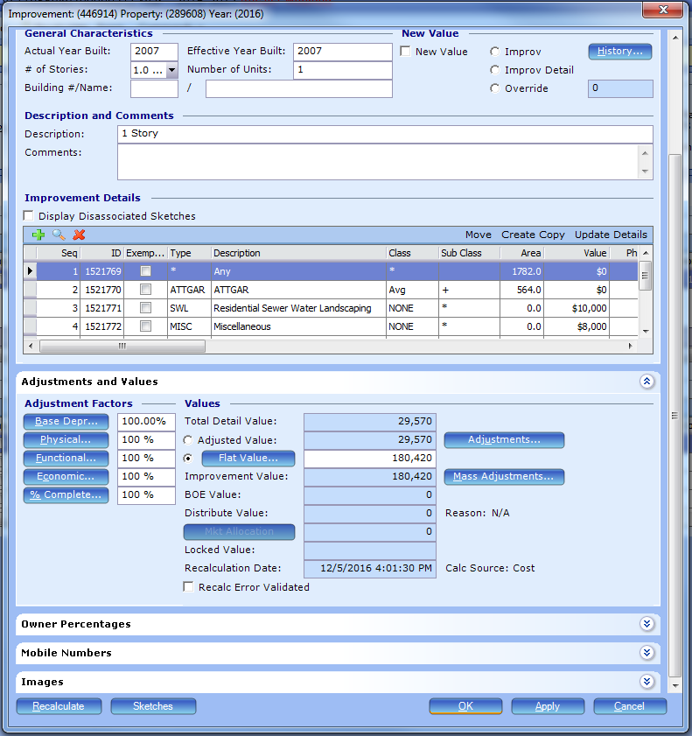
BOE Value and Distribute Value are remnants from the Texas product. We won’t use them.
Locked Value in the improvement details will show just the locked value of the improvement, not the entire locked value.

If sketching from plans, makes sure to validate the recalc error (check box). Pre-building in PACS increases efficiency.

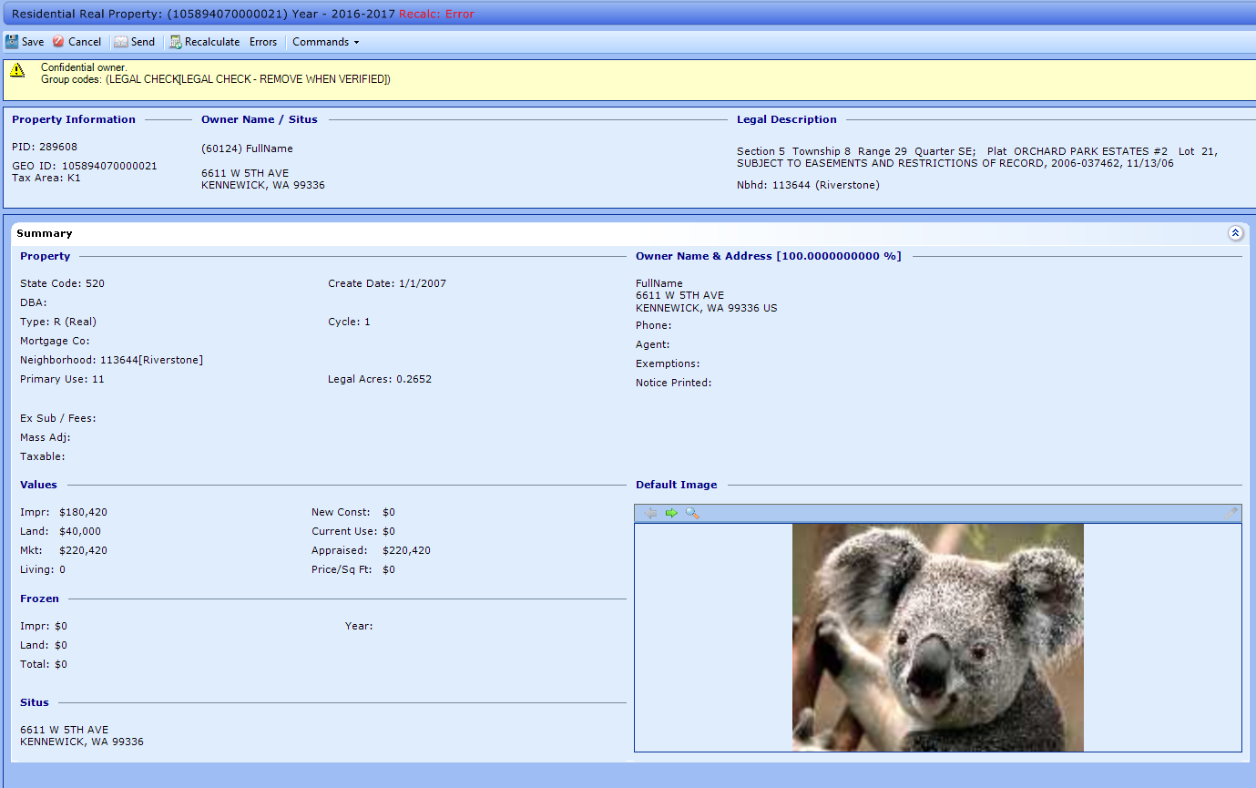
Can create group codes to notify of flat values due to pre-building new construction, etc.

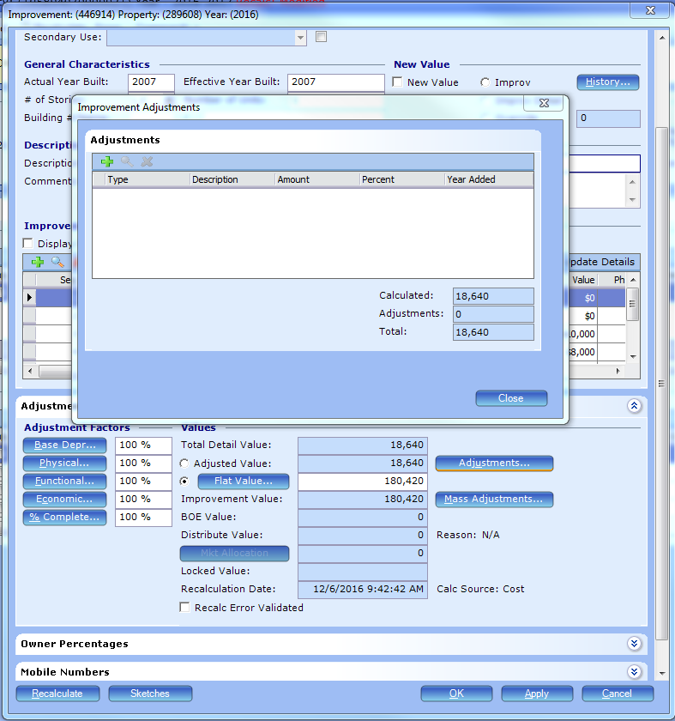
Click on the ‘adjustments’ button to the right to make adjustments for overimprovements, etc. Leave the ‘factors’ on the left side alone.

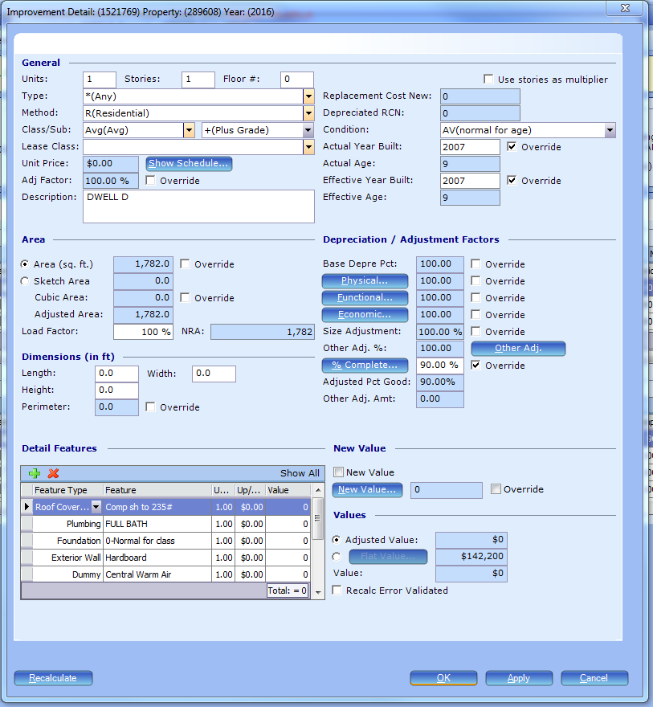
Improvement details.
Type, method, and class are needed to generate a value.
Unit, story, and floor are not necessary unless we are using them in our valuation tables. If type is flagged as use as base, you can use it to factor all of the other segments.
The main living area will have all of your features – bathrooms, hvac, roof type, siding, etc. A patio will not have the same details as the main area.
*The area will come over from the sketch*
Important: New Value is how you flag a detail as new construction. The flag of “new construction” will only go away if the detail is now at 100%. PACS keeps a record of that % compete progress.
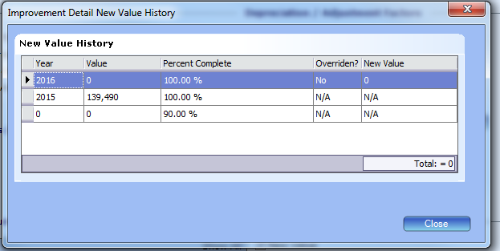

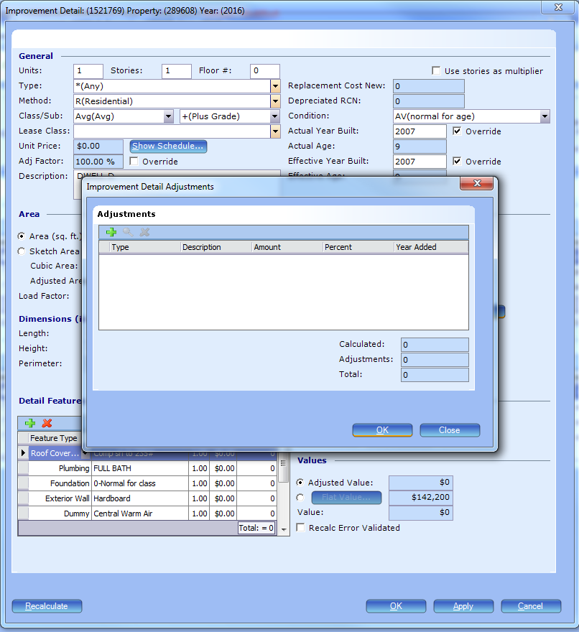
Adjustments at the detail level will only affect that specific detail, not the entire improvement.

Before values are sent, can run a report for all recalc errors. You can select the validated button if it is an acceptable reason to have an error (future year, pre-sketched, etc). Should be something that is done on a regular time table, monthly or quarterly is best.

Sketching

You can override the sketch area and go off of the totals of the improvement details if you wanted.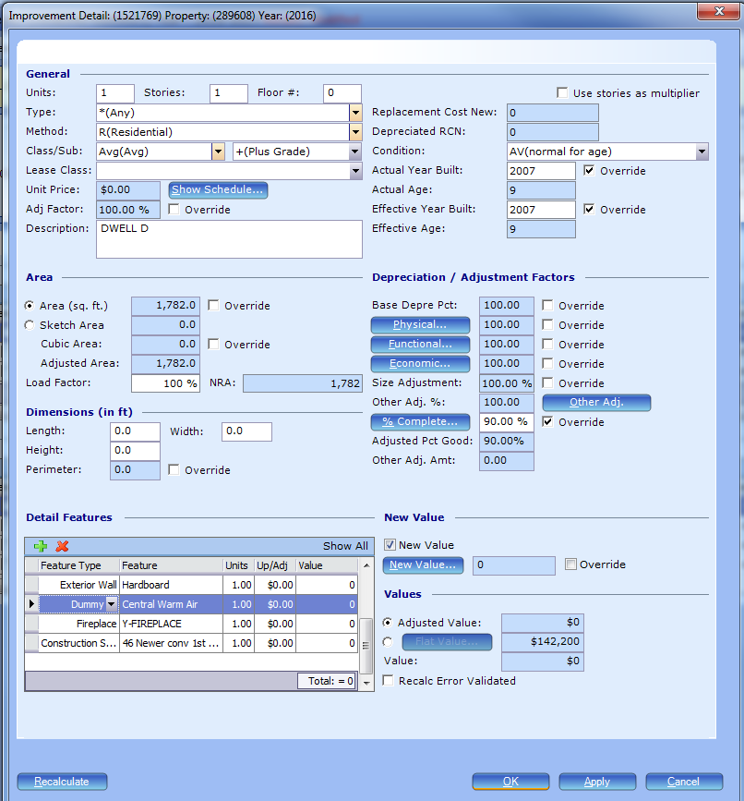
Access sketches at the improvement level.
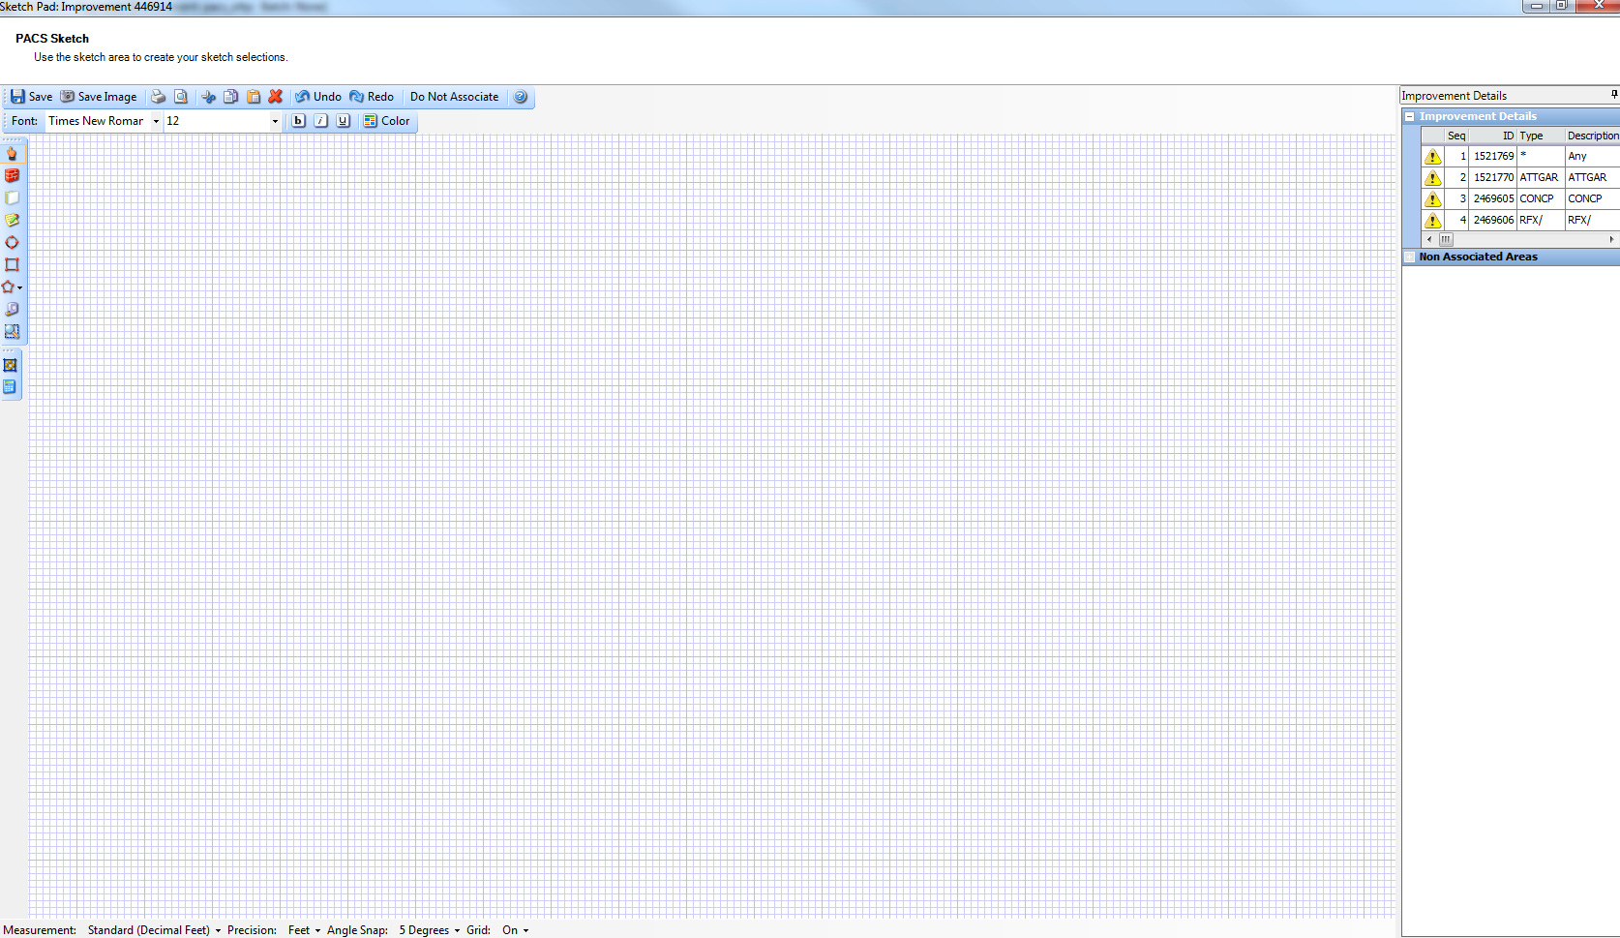
All of the details that make up an improvement. A sketched area has to be associated with a detail. Otherwise, PACS has no way of knowing what is supposed to be associated with what.
Select the detail on the right and sketch. That will associate with that detail.
‘a’ to auto close
The sketch is now associated with the detail.
‘c’ button centers the sketch.
‘Do Not Associate’ allows you to sketch areas without assigning them to specific improvement details. Also useful for sketching before you enter the details in.

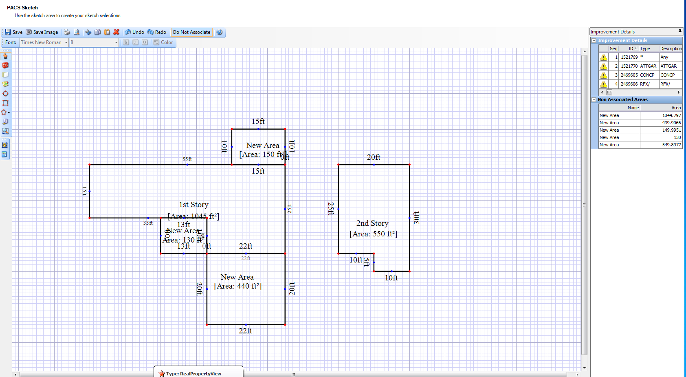

Try and use photometrics only for the building plans.
Saving a sketch creates two .jpeg images: sketch small and sketch large. These are used for the property record card.

Mass updating

Step one is to create a Batch. This allows you to undo if you mess something up.
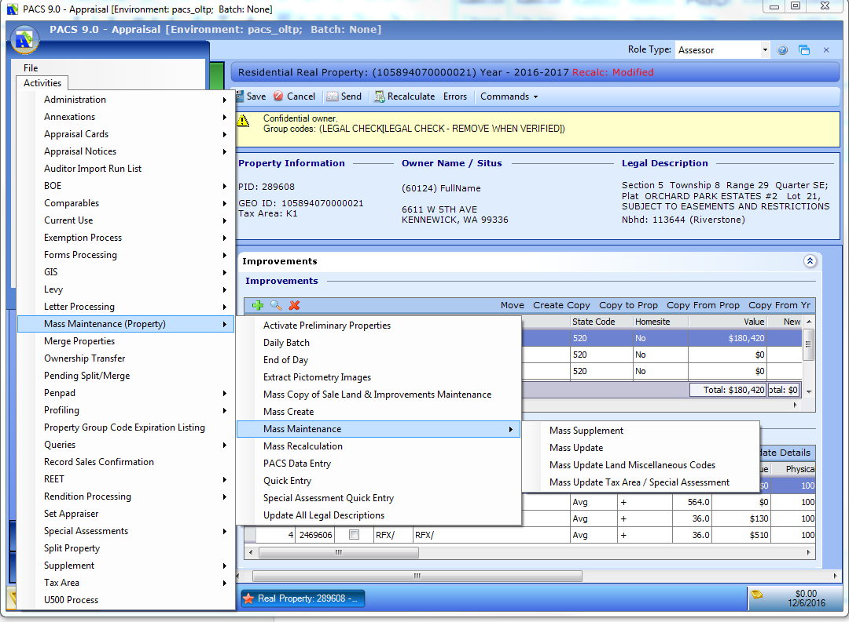
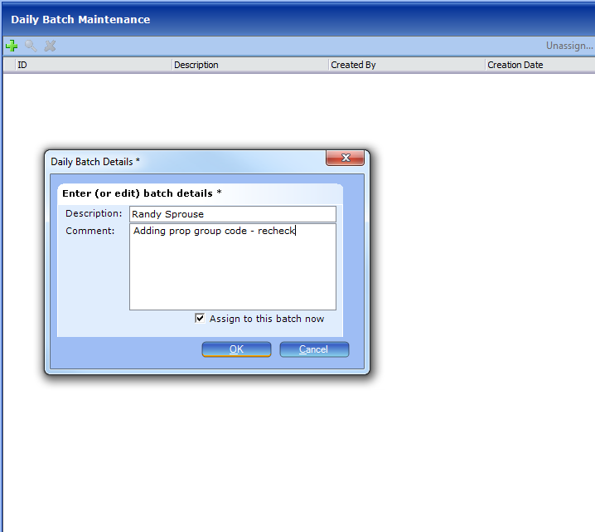
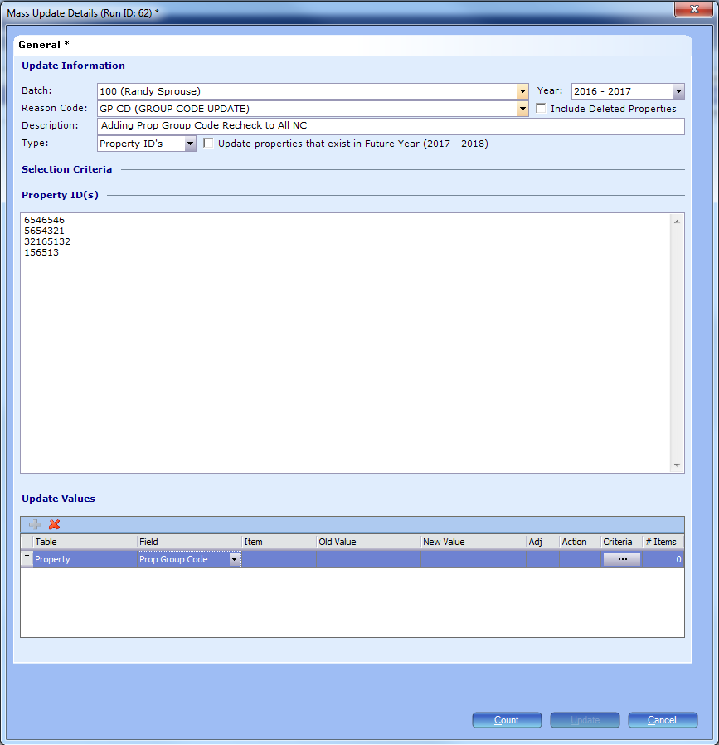
Can pull the data from a search, export to excel and put it back into the prop ids. Can also be pulled from another session of PACS.
Can also replace an old value with the new one. Action is insert to insert the new group code.

BOE
An inquiry is something that leads to a protest. Like a phone call or taxpayer coming into the office. Clark Co uses this as opposed to events when a taxpayer calls in with questions. The inquiry module does not have to be used at all.
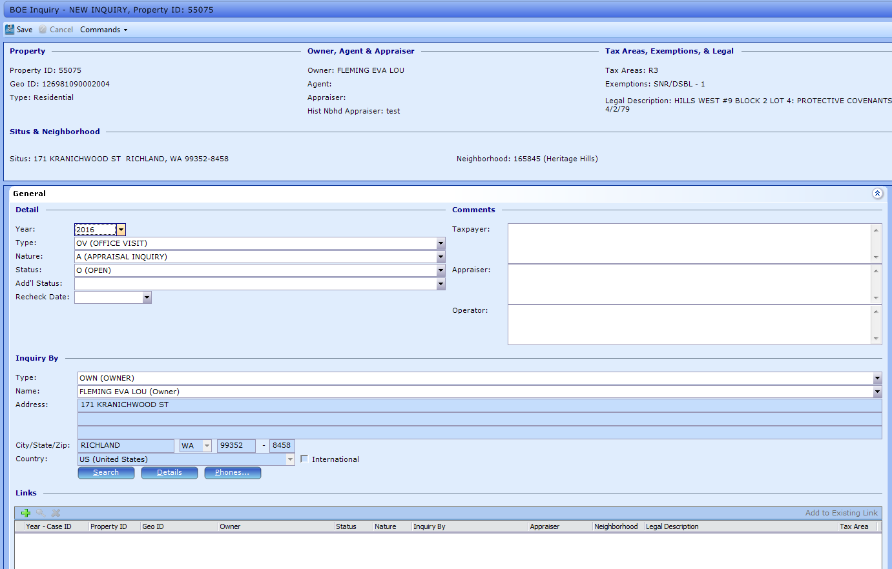
However, unlike Events, Inquiries can be turned into events. The BOE clerk will be creating the protests.

Supplements
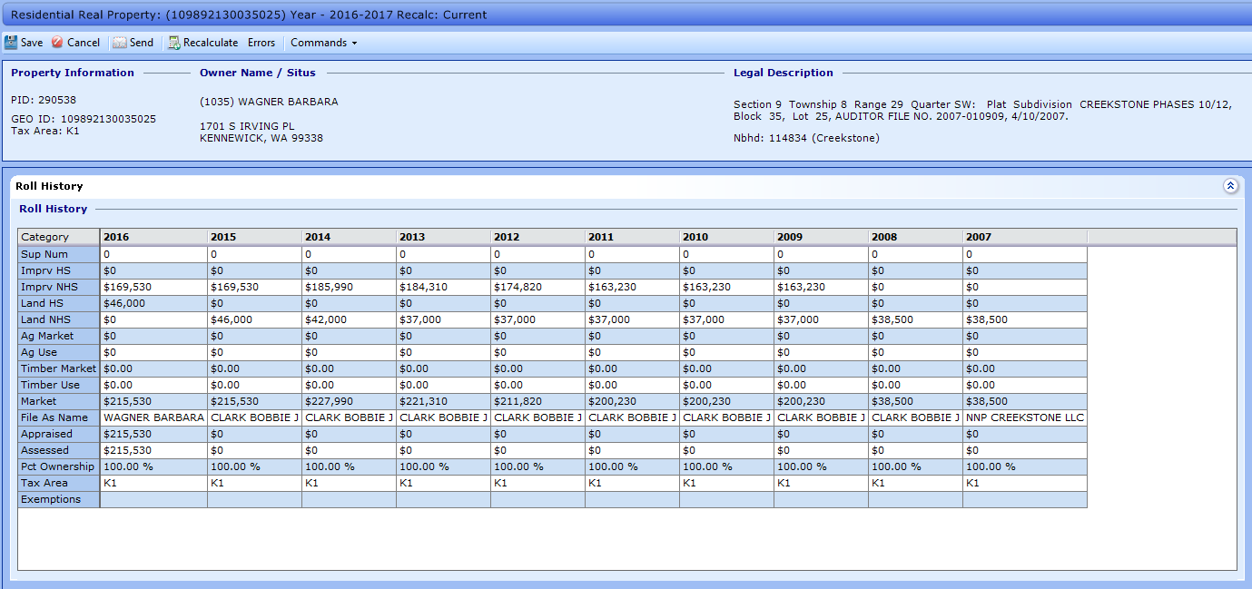
Sup Num does not refer to how many times the property has been supplemented, it is just a reference number that shows which supplement it lives in.
If PACS goes down and the ‘brain’ needs to be restarted, PACS needs to be notified by us. They aren’t automatically flagged unless we set that up.

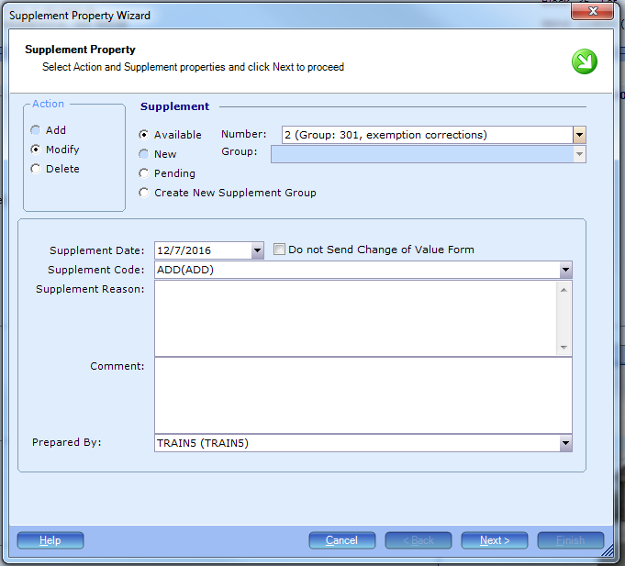
Modify will be 99.98% of the actions you will be performing in the supplement screen. These selections modify things on the Treasurer’s side. It does not change any functionality on the Assessor’s side.
Imagine a supplement group is a box, and the numbers are smaller boxes. The supplement group number and the supplement number have no relation to one another. DO NOT THINK THEY HAVE ANY RELATIONSHIP TO ONE ANOTHER.
Pending supplement group is a holding pattern, it never processes. At some point in time a property will need to be moved from here to an active supplement group.
Create a New Supplement Group is where things get nasty. Each group should have a purpose:
Value change group
Non-value change group
Exemption group
Etc.
This way, when you’re doing your reconciliations, everything is in similar groups for ease of balancing.
If there is an open supplement group for a given year, the wizard will default to available. Then you can hit the drop down menu and select an appropriate one.
Clark County opens supplement groups every morning, closes them at 4 PM and has supervisors run the supplement reports every day to reconcile. They also have a group for every single reason, approximately 12 groups.
Cannot have multiple supplements of the same year in one group. Multiple years, but only one of each year can exist in a group.
Supplement reasons are very specific. We don’t want any ‘any’ reasons. You can create further details and reasons in the Supplement Reason section. Information in here is required in order to process the supplement. Affidavits, building permits, reference numbers, etc. A comment is not required. You could always copy and paste the supplement reason into the comments, but that’s an office policy and not a requirement of PACS.
Hit next.
This will take you to a summary screen. It will give you your supplement group number, your supplement number, and the supplement year. Hit finish.
The supplement process opens up a certified year so you can make modifications to grayed out areas. This will help us to reach our statutory dates sooner and easier. When you supplement a property, anyone can make changes to it.
Be cognizant that if you see a supplemented year, someone else is probably working on it.
Commands tab – supplement – remove from supplement will remove the parcel from supplement. This is to be done if you made a mistake in putting the property into supplement when you weren’t supposed to.
If you make a change in 2012 and it needs to be changed from that date moving forward, you will have to supplement 2013, 2014, 2015, and 2016. PACS does not assume anything beyond the current year you are supplementing.
You can however, ‘copy back’. If you missed a property and picked it up in the current year, you can copy it back to prior years. PACS will also figure out the depreciation going backward from the first year you added it.
If you start a supplement or wizard FINISH IT. Before you go on break, lunch, whatever. FINISH IT.

Supplement Group Management

Once you’re done making changes to a property, you’re done. Close out of the property and notify supervisor that you’ve finished it.
Activity Button, activities, supplements, supplement group maintenance.
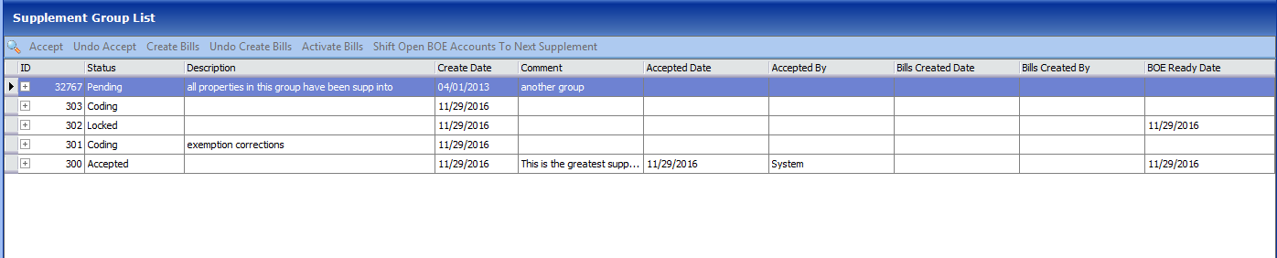

Pending is a great place to move properties that are being worked on, but aren’t ready to be finalized.
The sup num refers to the amount of supplements that exist within that year.

HelpSTAR – there is only one login per county office. The Assessor will have one and the Treasurer will have one. Important parts: what’s the problem and who do they need to contact?

PACS Admin
Tools – code file maintenance
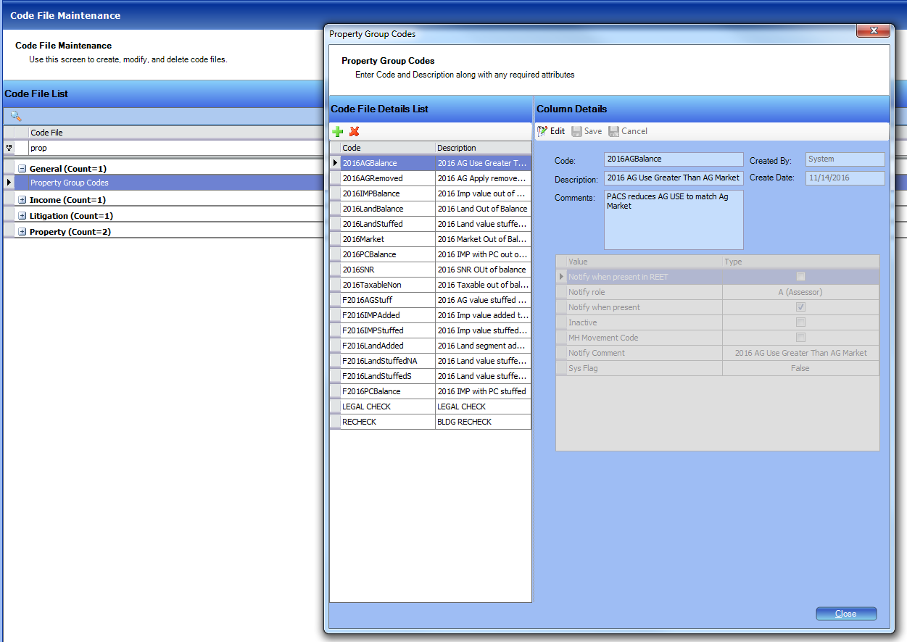

You can even create a group code with an appraiser’s initials, then they can search by those.
You can also inactivate these, so they don’t show up as selectable. Select the code and click ‘inactive’. This is also where you can set up the system flags and a comment that goes along with the flag.
IOLL = improvement on leased land.

GIS – parcel layer is your prop id layer.

Mass Adjustment
If you have solid schedules, you’ll want to do adjustments at the mass level.
At the identification level you will find the subdivision codes, etc
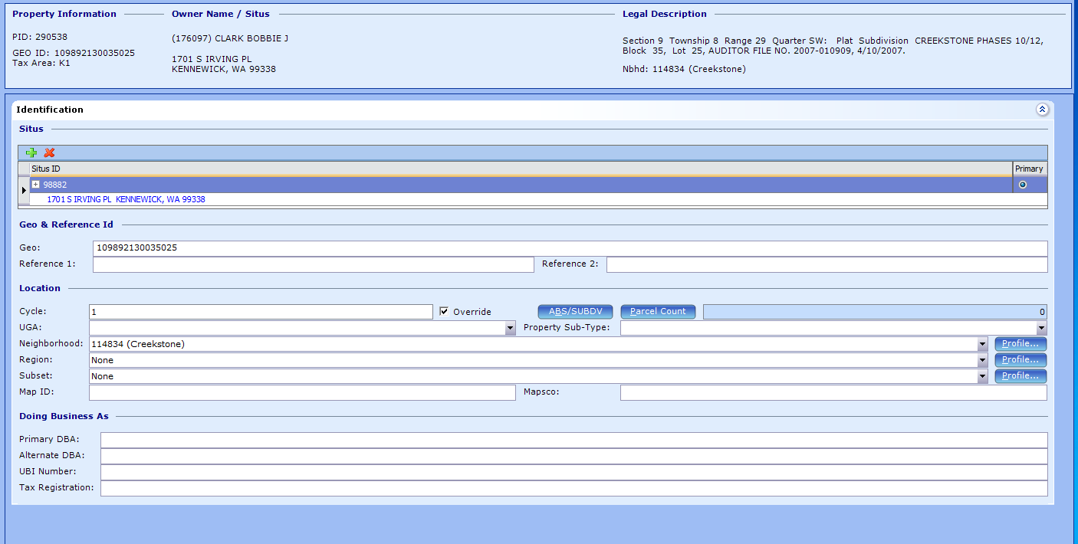
Neighborhood does not to be a geographic area, it can also be a market area.

Within admin:
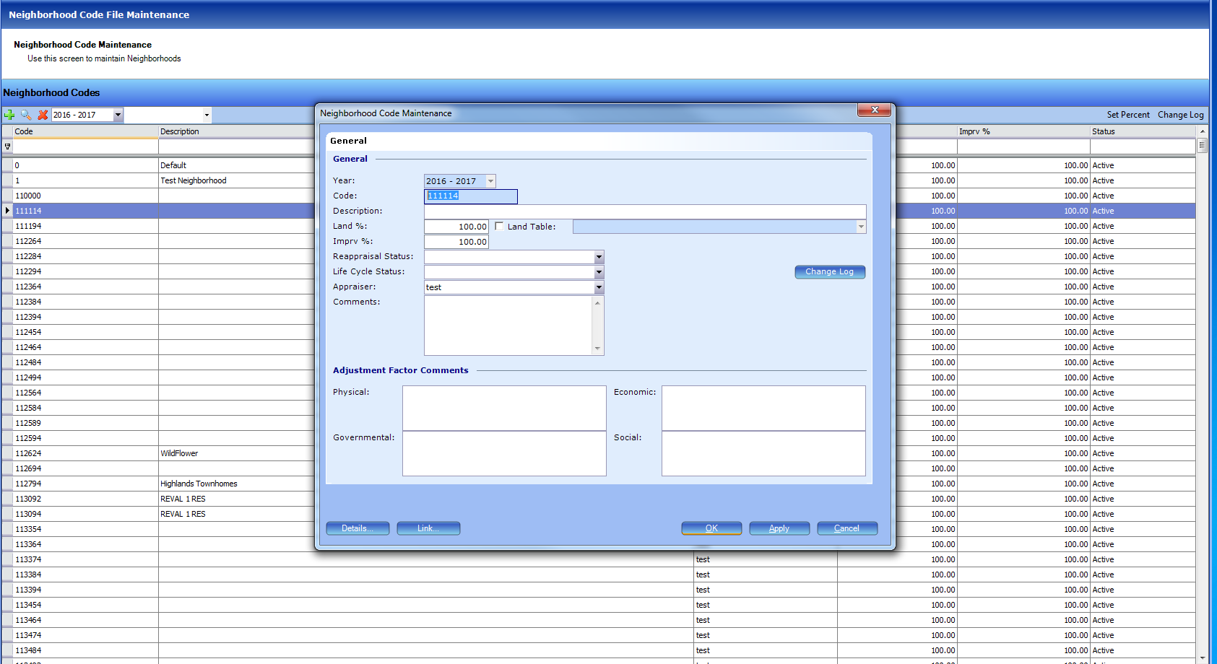

With the GIS analyst license, you can create neighborhoods using the GIS program.
Within the abstract subdivision code, you can further hone in on specific portions of a neighborhood.
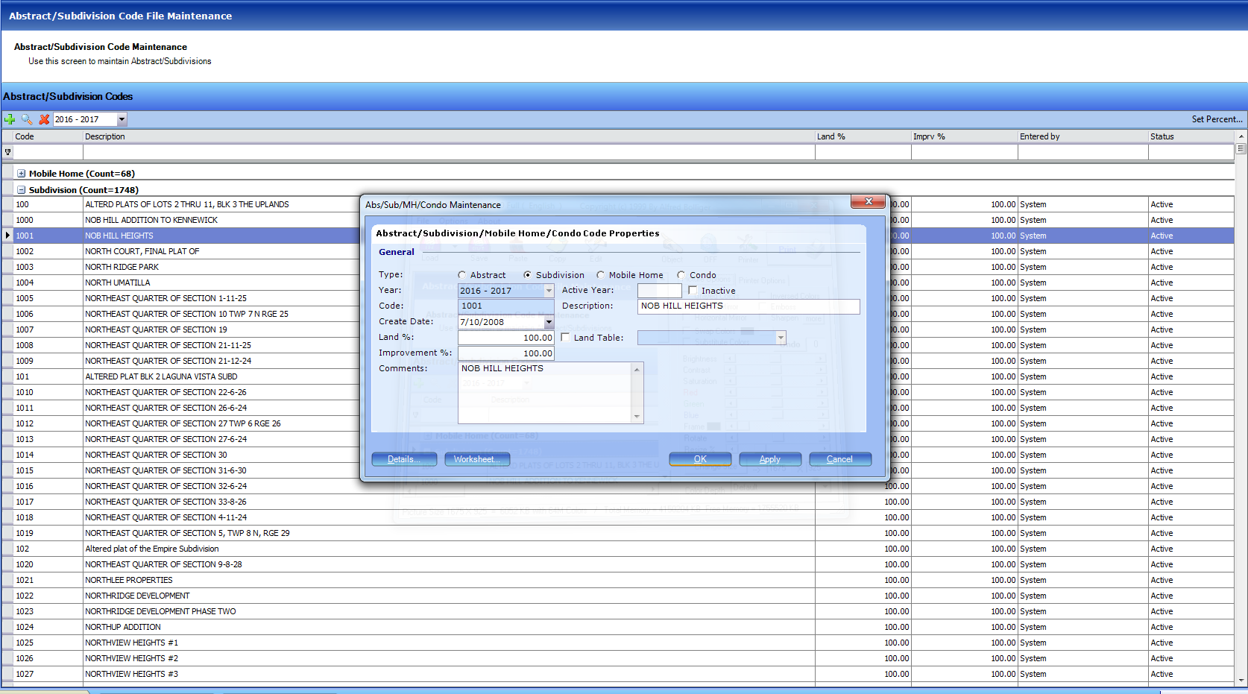

*Within mobile, assignment groups are typically neighborhoods.

As far as assignment groups, don’t do anything over 300 parcels. How many parcels could an appraiser do in a week? That’s the assignment group.
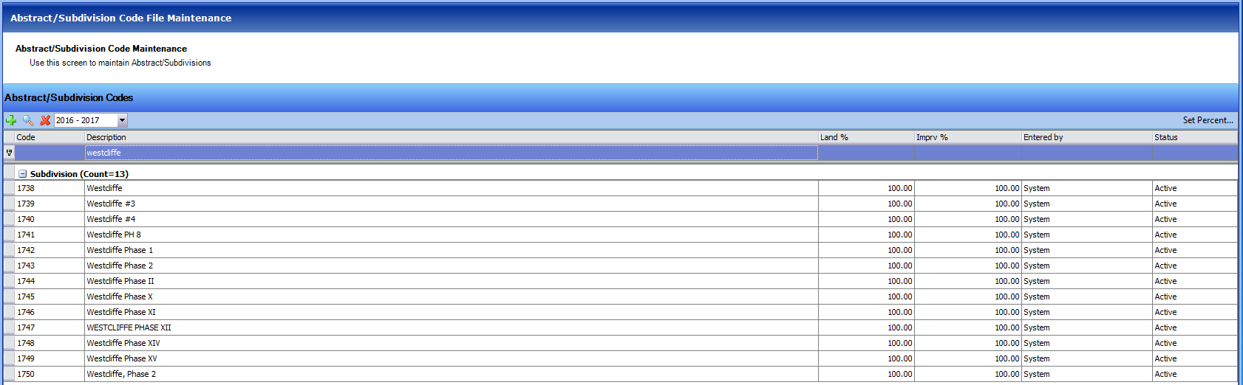
You can also set the percentage just by clicking set percent in the right hand side.

Can also create adjustments here:
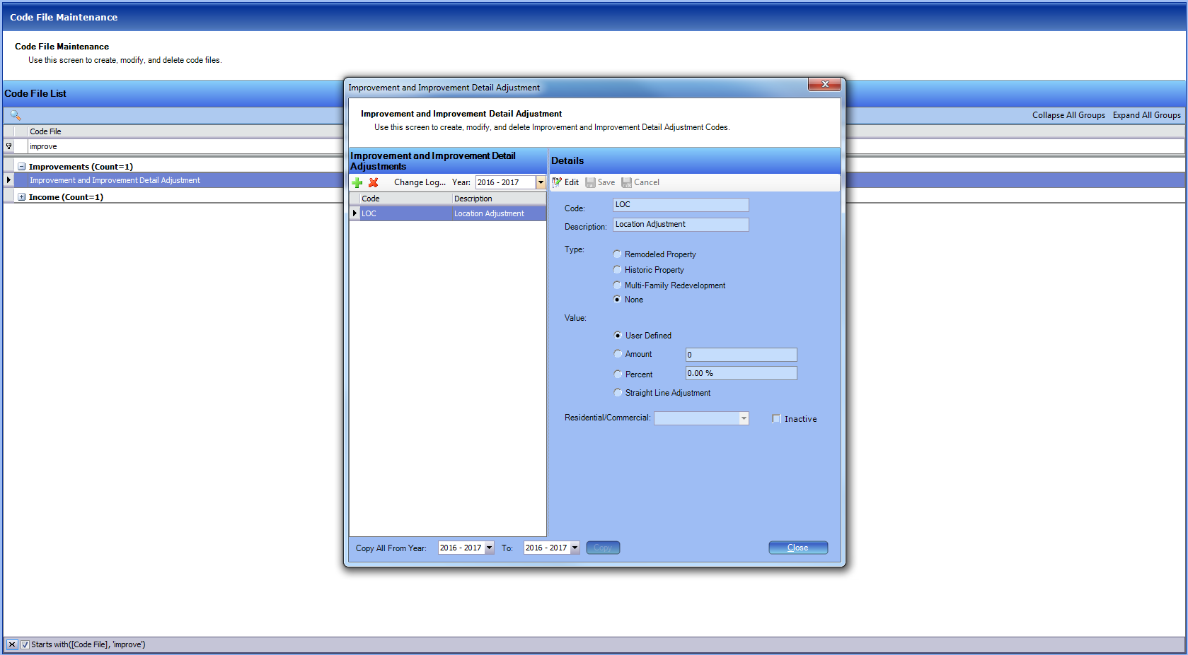
*This will give the appraisers the ability to apply the adjustment, but not set what that adjustment amount will be.

If you leave Residential/Commercial blank, it will allow you to apply it to any property.
Before you mass update, you need to create a batch.
After creating a batch, open GIS and select properties. Then right click and select mass update.
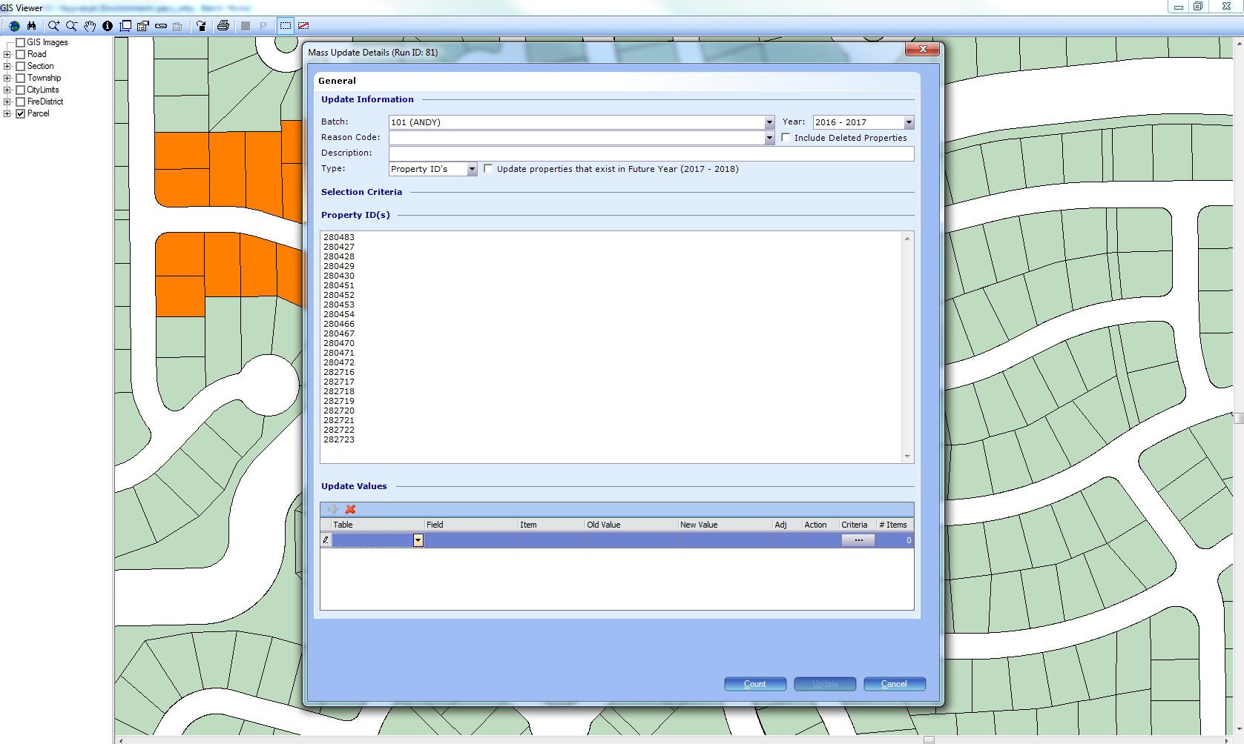
Can do multiple value updates at a time, so you can do a location adjustment, and then update the comment value to note that you made the adjustment.

Schedule maintenance
You can always see the schedule that is generating a value on the improvement detail level by clicking on show schedule.
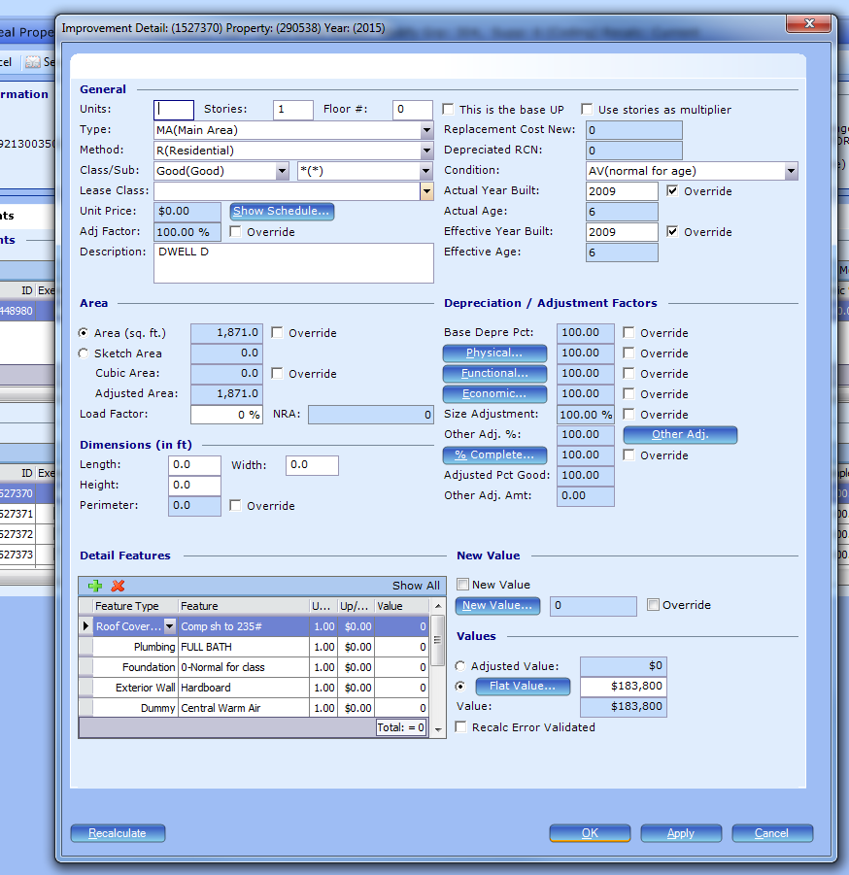
Interpolate means PACS will figure out the unit cost if a square footage is between the assigned values in the schedule, 1738 square feet for instance.
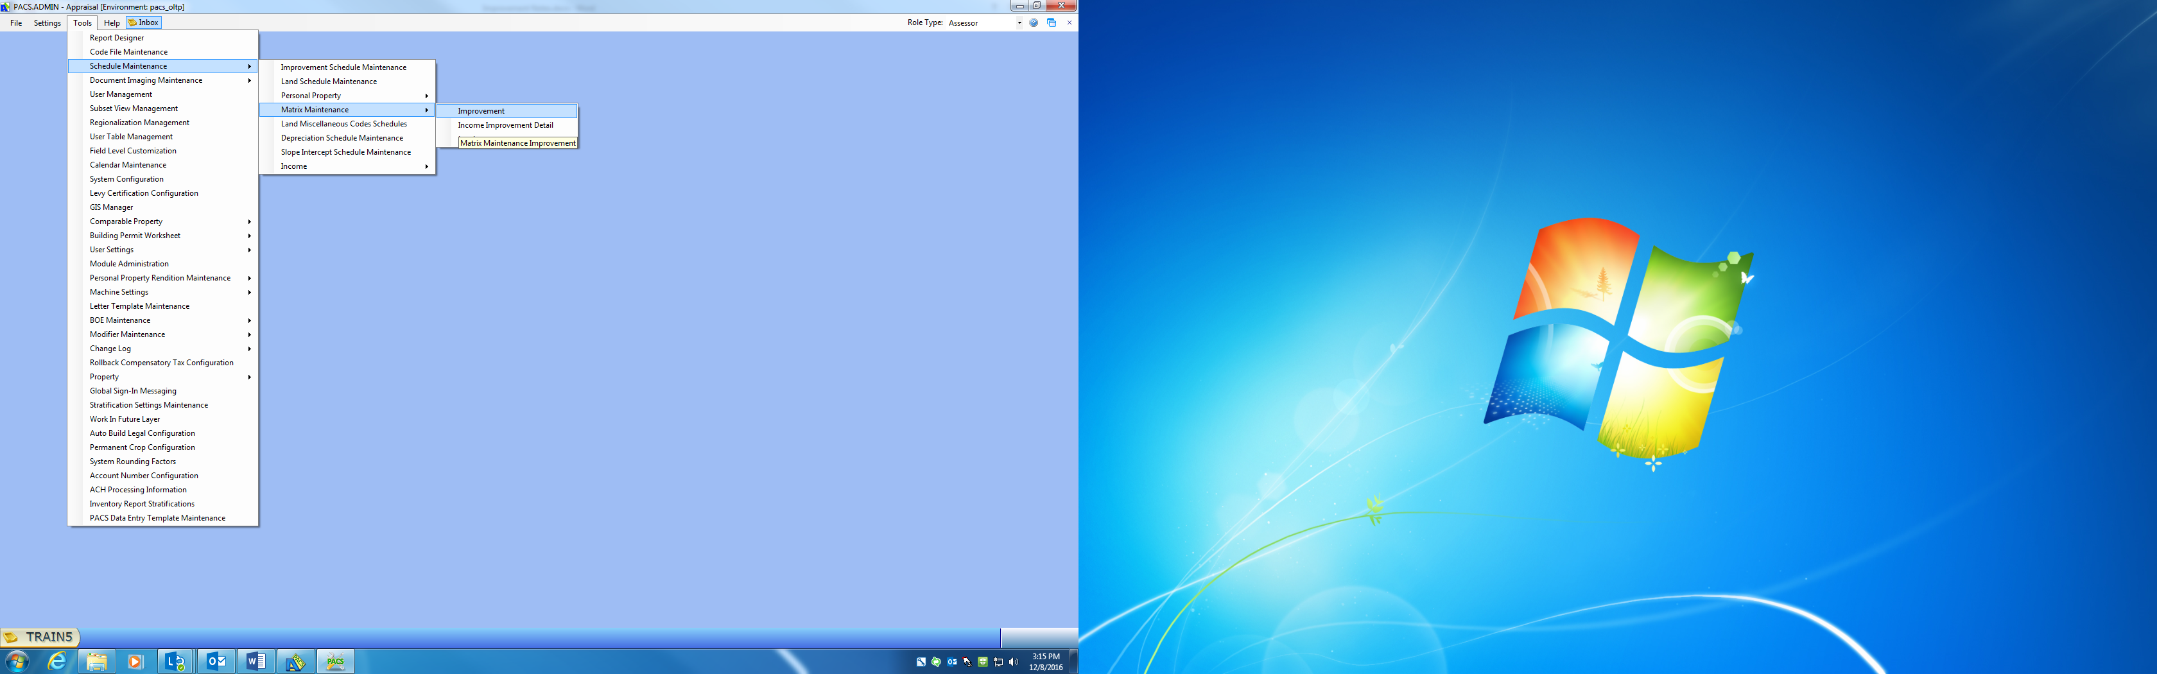

We want to focus on making things that aren’t MA a percent of base for simplification. Could even do % of base for second story.
For MA have quality as the horizontal axis and square footage as the vertical axis.

